Rebecca Mulholland

Rmulholland15@qub.ac.uk

<https://github.com/RebeccaMul/InsuranceCalculator>  
Version 1.0  
C# & .Net

Motor insurance application

SOFTWARE DOCUMENTATION

Table of Contents

Requirements: 2

## Requirements Specification:

1. **The policy details that can be entered:**
2. Required: Start Date of the Policy, E.g. 06/10/2015.
3. Required - Add Driver(s)
4. Required - Name: E.g. Brian.
5. Required - Occupation: ‘Chauffeur’ or ‘Accountant’.
6. Required - Date of Birth: E.g. 01/01/1973.
7. **Optional** – Add Claim(s) associated to the driver.

Required for each claim - Date of Claim: E.g. 01/01/2014.

1. A policy has a minimum of 1 and a maximum of 5 drivers.
2. A driver has a maximum of 5 Claims.
3. **Premium Calculation Rules:**

1. The starting point for the premium is £500.

2. Driver Occupation

1. If there is driver who is a Chauffeur on the policy increase the premium by 10%
2. If there is driver who is an Accountant on the policy decrease the premium by 10%

3. Driver Age

1. If the youngest driver is aged between 21 and 25 at the start date of the policy increase the premium by 20%
2. If the youngest driver is aged between 26 and 75 at the start date of the policy decrease the premium by 10%

4. Driver Claims

1. For each claim within 1 year of the start date of the policy increase the premium by 20%
2. For each claim within 2 - 5 years of the start date of the policy increase the premium by 10%
3. **Decline Rules**

1. If the start date of the policy is before today decline with the message "Start Date of Policy".

2. If the youngest driver is under the age of 21 at the start date of the policy decline with a message "Age of Youngest Driver" and append the name of the driver.

3. If the oldest driver is over the age of 75 at the start date of the policy decline with a message "Age of Oldest Driver" and append the name of the driver.

4. If a driver has more than 2 claims decline with a message "Driver has more than 2 claims" – include the name of the driver.

5. If the total number of claims exceeds 3 then decline with a message "Policy has more than 3 claims".

## Unit Implementation

### Step 1

**Filename:** Default.aspx/cs

**Brief Description:** *  
**Notable methods:**

* 1
* 2
* 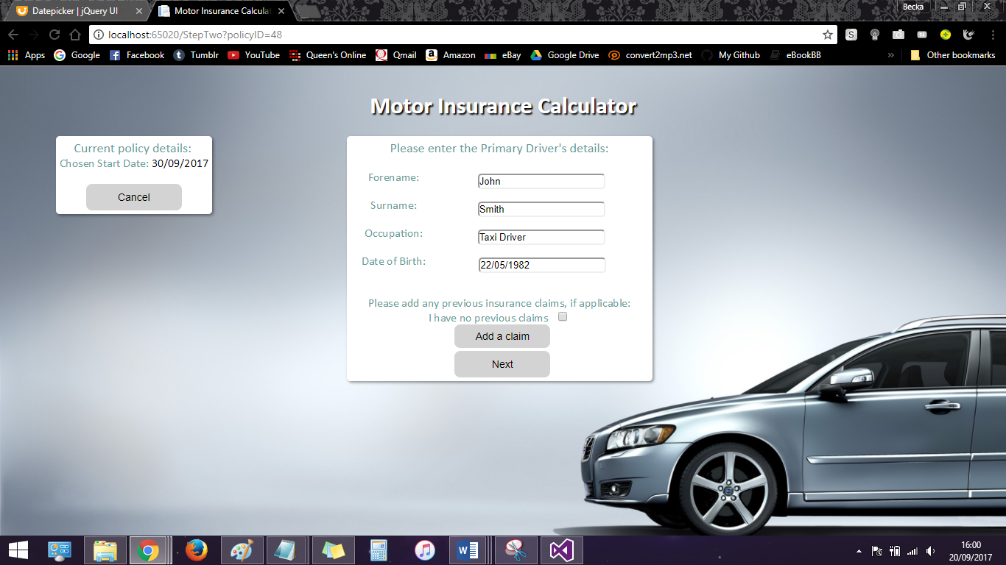3

### Step 2

**Filename:** StageTwo.aspx/cs  
**Brief Description:** *  
**Notable methods:**

* 1
* 2

### Step 3

**Filename:** StageThree.aspx/cs  
**Brief Description:** *  
**Notable methods:**

* 1
* 2

Step 4

**Filename:** Calculation.aspx/cs  
**Brief Description:** *  
**Notable methods:**

* 1

### Step 5

**Filename:** Result.aspx/cs  
**Brief Description:** *  
**Notable methods:**

## Unit Tests

## Database Design & ER Diagram

All user data and policy information is stored in a local Microsoft SQL Server database within the Program project.

*Diagram*